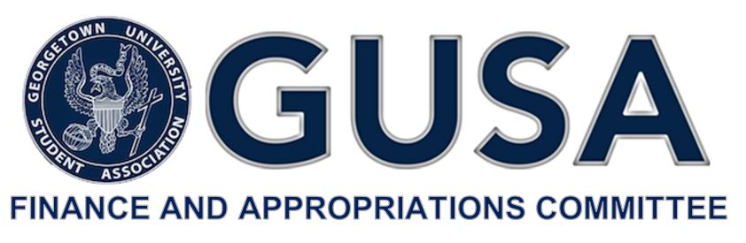

Dear Applicant,

Thank you for your interest in applying for funding from the Student Activities Fee for FY20. The Committee is excited to spend time getting to know the unique ways that your organization, program, or project contributes to the vitality of student life at Georgetown.

The following application is designed to give the Committee a better picture as to the impact your organization, program, or project makes on student life. The application is organized into three parts, A through C, explained in detail below. The Committee will hold two informational sessions to provide a comprehensive overview of the process and will hold office hours during the duration of the application period. Please refer to the email announcement of this application for specific dates and locations.

While the Committee will consider each Part B application it receives, it maintains the right to deny a Part B application from entrance into Budget Summit and full consideration for funding. As you complete your application, please keep in mind that the Committee will likely receive far more requests than the Student Activities Fee can accommodate. This fact necessitates the Committee make near-impossible judgements regarding the positive impact that each dollar allocated can make to enhance student life.

The Committee thanks you for the time and effort spent compiling your financial data and answering our questions. We look forward to working with you throughout this process.

Best Regards,

Hayley Grande

Chair, GUSA Finance and Appropriations Committee

GUSA Finance & Appropriations Committee

**FY20 Budget Summit**

Student Activity Fee Funding Application

(APPLICATION B- For Non-Advisory Boards)

Please email this application and accompanying materials to gusafinapp@georgetown.edu by **Sunday, February 10, 2019 at 11:59 pm.**

**PART A.**

Name of Organization: GUSA’s Sexual Assault and Student Safety Policy Team

Mission of Organization: To support student advocates committed to interpersonal violence prevention and response, to hold university administrators accountable in their duties to survivors of sexual assault on this campus.

GMS Worktags:

Cost center: CC2391

Program code: PG001225

Total Amount of Funding Requested: $1,500-$2,000 out of $4,700 total

**PART B.**

Please complete the Financial Information (B) FY20 excel document and attach it to your email submission.

The Sexual Assault and Student Safety Policy Team does not have a budget on its own, so I can’t really fill out the excel sheet. Informally, members of the outgoing executive have indicated that I would likely not be able to get more than $300 for this event from GUSA discretionary funds.

**PART C.**

Please answer the following questions in detail and provide any relevant documents:

1. Describe the program/project you would like to fund, implement or enhance.

I would like to bring Heather Marlowe to campus during April, which is Sexual Assault Awareness Month. Heather Marlowe is an activist and playwright who performs at college campuses around the country. You can read more about her play, *The Haze,* on her website: [www.thehazeplay.org](http://www.thehazeplay.org). Heather’s fee (including travel expenses) is $4,700. Heather is an artist, an activist, a woman of color and a survivor, and I believe it is incredibly important that Sexual Assault Awareness month includes some artistic spaces, especially spaces that center perspectives like hers, in addition to the more “speaker” and “workshop” oriented programming that normally takes place during Sexual Assault Awareness month. Heather’s performance requires very little tech, though we may need to pay a rental fee depending on the space we decide to rent out (I would currently like to do Copley Formal if we can, though McShain works as well). Heather also does a talk back and Q and A session after each performance.

1. How are decisions made about the direction of this program? How are students  
   involved in the decision making process?

Myself, Claire Smith, and Larry Huang (all students) are currently attempting to bring Heather to campus, but she has also been in touch with previous members of GUSA dating back to 2017, including Kamar Mack and Olivia Hinerfeld, all of whom have expressed interest in bringing her to campus in the past but have been unable to get the funds together.

1. In what ways does this program/project enhance student life at Georgetown  
   University? How many students will it affect?

Ideally we will be able to get a space that could seat between 160 and 200 people, all of whom would be able to see the play. Our campus is so wrapped up in issues of sexual assault, but so often we just focus on the perpetrator and think less about survivor’s lives after an assault. Heather has taken her trauma and turned it into a thought-provoking one-woman play and I think it would be really important to help us change the dialogue around issues of sexual assault on this campus.

1. What funding sources currently support this program? Will these sources continue to provide funding at the same level this year? What other sources have been explored before coming to GUSA?

I was planning on leaning heavily on Corp Philanthropy to bring Heather to campus, but they are no longer able to support the event financially. I have applied for money from the Georgetown Women’s Alliance, Lecture Fund, and Student Affairs, and may be able to get a very small amount from the GUSA Executive, but as this will be a GUSA co-sponsored event, I would hope that FinApp could contribute significantly to bringing this event to campus. As I said earlier, her entire fee is $4.7k, so any amount GUSA could contribute would be extremely helpful.

1. Will this program comply with all University policies? –– yes.
2. What level of financial risk does this project entail?

If we don’t get enough money, we can’t bring her to campus.

1. In what way will this program/project expand or relieve a financial burden on  
   students participating in this program?

Ideally, students will not need to purchase tickets for this event because we will pay for all associated fees through my current fundraising efforts. It is very important that students, especially survivors of assault and folks from other marginalized backgrounds, are not barred from attending this event because of financial barriers.

1. What is the long-term financial impact of this project? Will there be ongoing  
   maintenance costs?

n/a

1. Will this program need more money in future years? To the best of your ability  
   provide information on project costs for the next two years.

n/a

1. Has your organization/group previously applied to the Budget Summit? How much was the organization allocated? How was it used?

The Sexual Assault and Safety Policy Team has not applied for funding by itself in the recent past, as far as I am aware.

**CERTIFICATION:**

By signing below, I hereby certify that the information enclosed is accurate to the best of  
my knowledge.

**Funding Request Form Submitted By:** Grace Perret

**Name of Group Student Chair:** Grace Perret

**Signature (type your name):** Grace Perret

**Name of Group Advisor:** Erika Cohen Derr

**Signature (type your name):**

**Date:** 2/10/2019

**Contact Email:** gp413@georgetown.edu

**Contact Phone Number:** (504) 472-7338